**اللهم علمنا ما ينفعنا، وانفعنا بما علمتنا، وزدنا علما "سُبْحَانَكَ لا عِلْمَ لَنَا إِلَّا مَا عَلَّمْتَنَا إِنَّكَ أَنْتَ الْعَلِيمُ الْحَكِيم"**

**Adaptive Median Filtering Example**

Suppose we have the following 7x7 image:

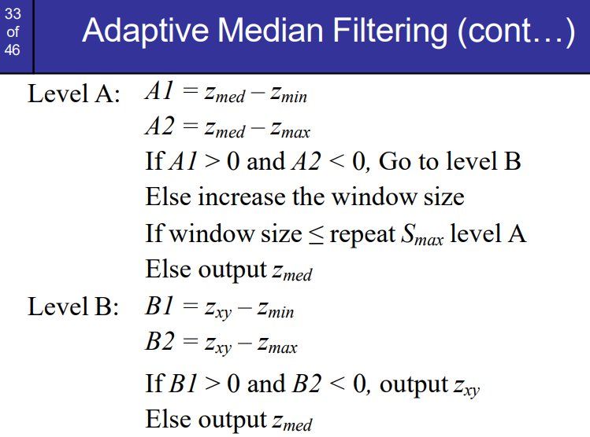Pixels = [

[50, 51, 52, 53, 54, 55, 56],

[57, 58, 59, 60, 61, 62, 63],

[64, 65, 66, 67, 68, 69, 70],

[71, 72, 73, 74, 75, 76, 77],

[78, 79, 80, 81, 82, 83, 84],

[85, 86, 87, 88, 89, 90, 91],

[92, 93, 94, 95, 96, 97, 98]]

And we want to apply the Adaptive Median Filtering algorithm with a 3x3 mask.

Let's start with the pixel at (2, 2)

1. The 3x3 window around the pixel (2, 2) is

Window = [[58, 59, 60],

[65, 66, 67],

[72, 73, 74]]

* Zmax = 74
* Zmed = 66
* Zmin = 58
* Zxy = 66

2. Calculate A1 and A2:

- A1 = Zmed – Zmin = 66 – 58 = 8

- A2 =Zmed - Zmax = 66 – 74 = -8

3. Check the conditions:

- Since A1 > 0 and A2 < 0, we move to Level B.

4. Calculate B1 and B2:

- B1 = Zxy – Zmin = 66 - 58 = 8

- B2 = Zxy – Zmax = 66 - 74 = -8

5. Check the conditions:

- Since B1 > 0 and B2 < 0, we output Zxy, Else output Zmed

- Result [2, 2] = 66

You can continue this process for the remaining pixels in the 7x7 image using the 3x3 mask.

**Example2:**

With a 7x7 image where the pixel values are not sorted. We will then apply the Adaptive Median Filtering algorithm using a 3x3 mask.

* Given 7x7 Image

Pixels = [

[80, 20, 50, 40, 10, 70, 60],

[30, 90, 10, 80, 20, 50, 40],

[60, 70, 30, 20, 90, 10, 80],

[50, 40, 80, 70, 60, 20, 30],

[10, 30, 70, 90, 40, 50, 60],

[20, 10, 50, 40, 30, 80, 70],

[90, 80, 60, 10, 20, 30, 50]]

* Example Calculation for Pixel (2, 2)
* 3x3 Window for Pixel (2, 2):

Window = [

[90, 10, 80],

[70, 30, 20],

[40, 80, 70]]

Sorted: 10 20 30 40 70 70 80 80 90

* Zmax = 90
* Zmed = 70
* Zmin = 10
* Zxy = 30

- Calculate A1 and A2:

- A1 = Zmed – Zmin = 70 – 10 = 60

- A2 =Zmed - Zmax = 70 – 90 = -20

- Check the conditions:

- Since A1 > 0 and A2 < 0, we move to Level B.

- Calculate B1 and B2:

- B1 = Zxy – Zmin = 30 – 10 = 20

- B2 = Zxy – Zmax = 30 – 90 = -60

- Check the conditions: Since B1 > 0 and B2 < 0, we output Zxy, Else output Zmed

Result [2, 2] = 30